**Quarterly Report – Public Page**

**Date of Report:** 7th Quarterly Report - July 3, 2024

**Contract Number:** *693JK32210015POTA*

**Prepared for:** *DOT-PHMSA*

**Project Title:** *Dynamic Geohazard Risk and Decision Support Platform*

**Prepared by:**  *Boston Geospatial, Inc.*

**Contact Information:**  *Justin Oliveira,* [*justin@bostongeospatial.com*](mailto:justin@bostongeospatial.com)*, 321-720-3568*

**For quarterly period ending:** *June 30, 2024*

**1: Items Completed During this Quarterly Period:**

A detailed overview of the progress this past quarter is provided in the various sections below.

| ***Item #*** | ***Task #*** | ***Activity/Deliverable*** | ***Title*** |
| --- | --- | --- | --- |
| 21 | 4.3 | Load Case Module | Submit Load Case API Documentation |
| 18 | 6.1 | GIS Interface | ArcGIS interface initialization, geodatabase connections, and dashboard setup |
| 22 | 6.2 | GIS Interface | ArcGIS Web Portal Setup |
| 29 | 0.1 | 7th Quarterly Status Report | Submit 7th quarterly report |

**2: Items Not-Completed During this Quarterly Period:**

| ***Item #*** | ***Task #*** | ***Activity/Deliverable*** | ***Title*** |
| --- | --- | --- | --- |
| 23 | 6.3 | GIS Interface | Submit GIS Implementation Guideline Documentation |
| 24 | 7.1 | Integration | API service integration and client management setup; ArcGIS tool ribbon development |
| 25 | 7.2 | Integration | Submit consolidated API documentation and ArcGIS ribbon user's manual |
| 26 | 8.1 | Backtesting | Backtesting of tool with TAP operators |
| 28 | 8.1 | Backtesting | Backtesting of tool with TAP operators |

**3: Project Financial Tracking During this Quarterly Period:**

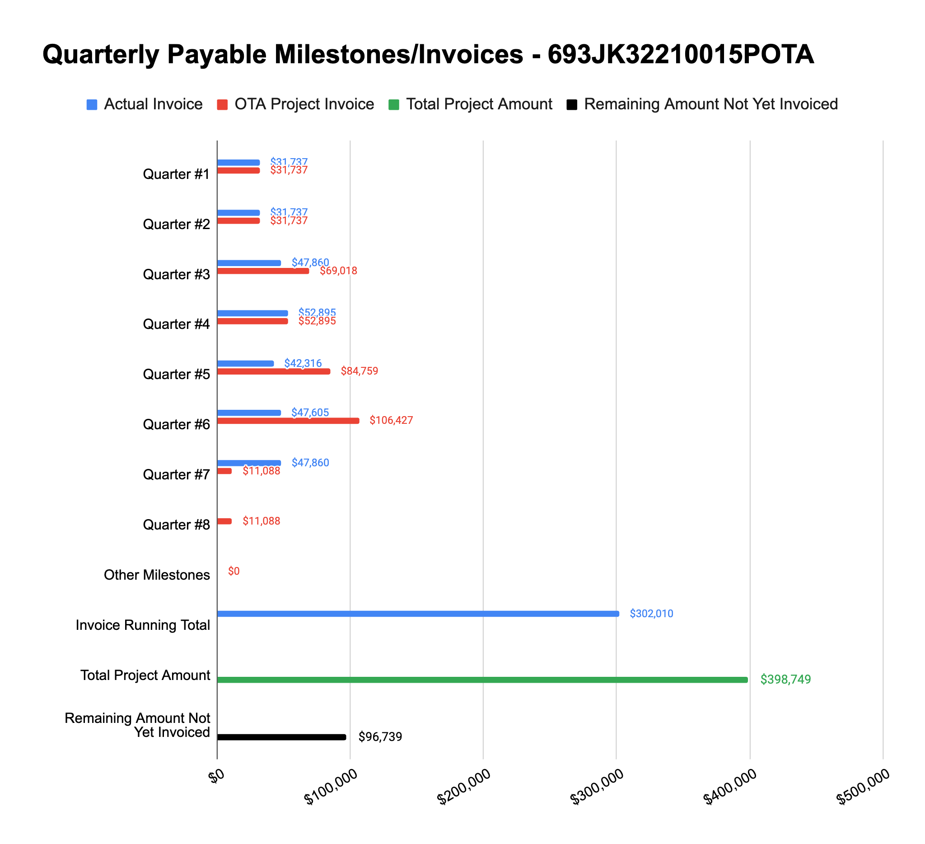

**4: Project Technical Status –**

[COPY/PASTE FROM non-public report]

**5: Project Schedule –**

Overall our project is about 5-7 weeks behind schedule. In mid June we submitted a request for a no-cost extension that would add about 2-3 months to the schedule. This would be used to finalize the ribbon development and not rush things - we’d like to perform extensive QA testing of the scripts before finalizing the Task area. A majority of the extra time will be used to perform backtesting on as many case studies from the 2022 PHMSA Geohazard Bulletin as possible prior to peer review process kickoff.